**Python**

1.https://github.com/pritam-777/Interview-Assesment/blob/main/Python%20Assesment.ipynb

2.https://github.com/pritam-777/Interview-Assesment/blob/main/Python%20Assesment.ipynb

3.

4.https://github.com/pritam-777/Interview-Assesment/blob/main/Python_Json_Question-4.ipynb

5.https://github.com/pritam-777/Interview-Assesment/blob/main/Python_Json_Question-5.ipynb

6.https://github.com/pritam-777/Interview-Assesment/blob/main/Python_Json_Question-6.ipynb

7.

8.

9.https://github.com/pritam-777/Interview-Assesment/blob/main/Python_Json_Question-9.ipynb

10.

**Statistics**

1. A correlation coefficient of 0.7 indicates a strong positive relationship between SAT scores and college GPA. This means that there is a tendency for students with higher SAT scores to have higher college GPAs, and vice versa. The positive sign of the correlation coefficient indicates that as SAT scores increase, college GPAs also tend to increase.

2.

A. Using the Z table, we find that the area to the left of z = -1 is approximately 0.1587, and the area to the left of z = 1 is approximately 0.8413.

To find the percentage between 160 cm and 180 cm, we subtract the area to the left of z = -1 from the area to the left of z = 1:

0.8413 - 0.1587 = 0.6826

Therefore, approximately 68.26% of individuals in the dataset have heights between 160 cm and 180 cm.

B. Using the standard normal distribution table (or a calculator), we find that the area to the left of z = 5 is almost 1. Therefore, the probability that the average height of the 100 individuals is greater than 175 cm is approximately 1.

C. z-score corresponding to a height of 185 cm, we use the formula: z = (x - μ) / σ, where x is the individual value, μ is the mean, and σ is the standard deviation.

z = (185 - 170) / 10 = 1.5

Therefore, the z-score corresponding to a height of 185 cm is 1.5

D. Using the standard normal distribution table (or a calculator), we look for the z-score that has a cumulative probability of 0.05. The closest value is approximately -1.645.

We can then use the z-score formula to find the height corresponding to this z-score: x = μ + (z * σ), where x is the individual value, μ is the mean, σ is the standard deviation, and z is the z-score.

170+(-1.645*10)=153.55 so +153.55 to -153.55

E.The coefficient of variation (CV) is a measure of relative variability and is calculated as the ratio of the standard deviation to the mean, expressed as a percentage.

In this case, the mean height is 170 cm, and the standard deviation is 10 cm.

CV = (standard deviation / mean) * 100

= (10 / 170) * 100

= 5.88

Therefore, the coefficient of variation for the dataset is approximately 5.88%.

F. he skewness of the dataset, we need to use the formula for skewness:

Skewness = (3 * (Mean - Median)) / Standard Deviation

Given that the dataset is approximately normally distributed and has a skewness close to zero

3. <https://github.com/pritam-777/Statistics-For-Data-Science/blob/main/Task-3.ipynb>

4.Since there are 20 friends and each can write any number between 1 and 20, there are 20 possible numbers for each friend. Therefore, the total number of possible outcomes is 20.

Number of favorable outcomes:

There are four perfect square numbers between 1 and 20: 1, 4, 9, and 16. So, there are four favorable outcomes.

Probability calculation:

Probability = (Number of favorable outcomes) / (Total number of possible outcomes)

Probability = 4 / 20

Simplifying the fraction, we get:

Probability = 1 / 5

5.

According to Bayes' theorem:

P(A|B) = (P(B|A) * P(A)) / P(B)

P(B|A) is the probability that the taxi is late given that it belongs to Company A, which is equal to 1 - 0.95 = 0.05 (since the success rate of Company A's taxis is 95%).

P(A) is the probability that a randomly selected taxi belongs to Company A, which is 0.8 (given that Company A has 80% of the taxis).

P(B) is the probability that the taxi is late, regardless of which company it belongs to. This can be calculated by considering the probabilities of being late for each company and taking into account the proportion of taxis each company has:

P(B) = P(B|A) * P(A) + P(B|B) * P(B)

P(B|B) is the probability that the taxi is late given that it belongs to Company B, which is equal to 1 - 0.90 = 0.10 (since the success rate of Company B's taxis is 90%).

P(B|A) * P(A) is the probability that the taxi is late and belongs to Company A.

Substituting the values into the equation:

P(B) = (0.05 * 0.8) + (0.10 * 0.2)

= 0.04 + 0.02

= 0.06

Now, we can calculate P(A|B) using Bayes' theorem:

P(A|B) = (P(B|A) * P(A)) / P(B)

= (0.05 * 0.8) / 0.06

= 0.04 / 0.06

≈ 0.6667

Therefore, the probability that a randomly selected taxi, given that it is late, belongs to Company A is approximately 0.6667 or 66.67%.

6.

7.

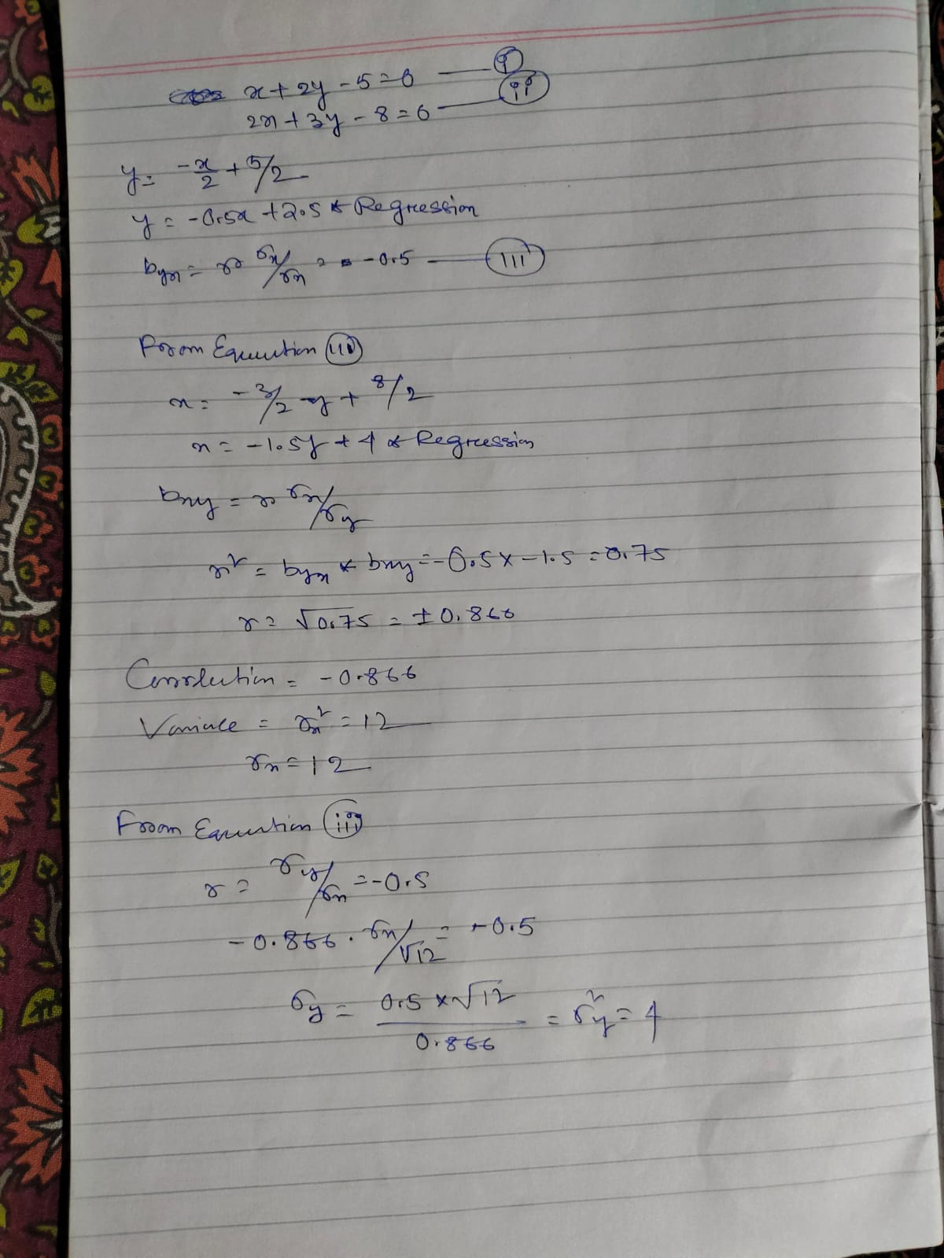

8.

9.

10.

a. Probability of exactly 20 bulbs being defective:

Using the binomial distribution formula, the probability can be calculated as follows:

P(X = 20) = C(n, x) * p^x * (1 - p)^(n - x)

where:

n = total number of bulbs = 500

x = number of defective bulbs = 20

p = probability of a bulb being defective = 0.05

Plugging in the values:

P(X = 20) = C(500, 20) * (0.05)^20 * (1 - 0.05)^(500 - 20)

b. Probability of at least 10 bulbs being defective:

To calculate the probability of at least 10 bulbs being defective, we need to sum up the probabilities of 10 or more defective bulbs. It can be calculated as follows:

P(X ≥ 10) = P(X = 10) + P(X = 11) + ... + P(X = 500)

We can use a binomial calculator or a statistical software to calculate this sum.

c. Probability of at most 15 bulbs being defective:

To calculate the probability of at most 15 bulbs being defective, we need to sum up the probabilities of 0 to 15 defective bulbs. It can be calculated as follows:

P(X ≤ 15) = P(X = 0) + P(X = 1) + ... + P(X = 15)

Again, we can use a binomial calculator or a statistical software to calculate this sum.

d. Average number of defective bulbs:

The average number of defective bulbs in a batch of 500 can be calculated using the mean of a binomial distribution formula:

Mean (μ) = n * p

where:

n = total number of bulbs = 500

p = probability of a bulb being defective = 0.05

Plugging in the values:

Mean (μ) = 500 * 0.05

11.

12.

Step 1: State the null and alternative hypotheses:

The null hypothesis (H0): There is no significant difference between the mean improvement scores of Group A and Group B.

The alternative hypothesis (Ha): There is a significant difference between the mean improvement scores of Group A and Group B.

Step 2: Select the appropriate t-test:

Since we are comparing the means of two independent groups, we will use an independent samples t-test.

Step 3: Define the significance level:

The significance level (α) is given as 0.05.

Step 4: Calculate the t-value:

We can calculate the t-value using the following formula:

t = (mean of Group A - mean of Group B) / sqrt((squared standard deviation of Group A / sample size of Group A) + (squared standard deviation of Group B / sample size of Group B))

Using the provided data:

Mean improvement score for Group A = 2.5

Standard deviation of improvement for Group A = 0.8

Sample size of Group A = 30

Mean improvement score for Group B = 2.2

Standard deviation of improvement for Group B = 0.6

Sample size of Group B = 30

Calculating the t-value:

t = (2.5 - 2.2) / sqrt((0.8^2 / 30) + (0.6^2 / 30))

Step 5: Determine the degrees of freedom:

Degrees of freedom (df) can be calculated using the following formula:

df = (squared standard deviation of Group A / sample size of Group A + squared standard deviation of Group B / sample size of Group B)^2 / ((squared standard deviation of Group A / sample size of Group A)^2 / (sample size of Group A - 1) + (squared standard deviation of Group B / sample size of Group B)^2 / (sample size of Group B - 1))

Calculating the degrees of freedom:

df = ((0.8^2 / 30) + (0.6^2 / 30))^2 / (((0.8^2 / 30)^2 / (30 - 1)) + ((0.6^2 / 30)^2 / (30 - 1)))

Step 6: Find the critical t-value:

The critical t-value can be found using the significance level (α) and the degrees of freedom (df). Since the significance level is 0.05, we will find the t-value at α/2 = 0.025 for a two-tailed test.

Step 7: Compare the calculated t-value with the critical t-value:

If the calculated t-value is greater than the critical t-value, we reject the null hypothesis; otherwise, we fail to reject the null hypothesis.

Step 8: State the conclusion:

Based on the comparison, we can state whether the null hypothesis should be rejected or not and provide a conclusion in the context of the study.

**Machine Learning**

1. <https://github.com/pritam-777/Instagram-Reach-Analysis-prediction/tree/main/Notebook>
2. <https://github.com/pritam-777/obseity-level-classification>
3. No Answer
4. <https://github.com/pritam-777/Online-Shoppers-Intention>
5. <https://github.com/pritam-777/Uber-and-Lyft-Dataset-Boston>
6. <https://github.com/pritam-777/Home-Loan-Prediction>
7. No Answer
8. <https://github.com/pritam-777/Quora-question-pair-similarity-prediction>
9. <https://github.com/pritam-777/Microsoft-Malware-prediction>
10. <https://github.com/pritam-777/Click-Through-Rate-prediction>

**Deep Learning**

1. <https://colab.research.google.com/drive/1bJRhGgl2JM7bl_rj7k7RTH5gSOVl1ohw?usp=sharing>
2. <https://github.com/pritam-777/CNN-Architecture-With-Pytorch>
3. <https://colab.research.google.com/drive/1bJRhGgl2JM7bl_rj7k7RTH5gSOVl1ohw?usp=sharing>